FWC IITH INTERNSHIP
DIGITAL – DESIGN
PlatformIO:
Question:
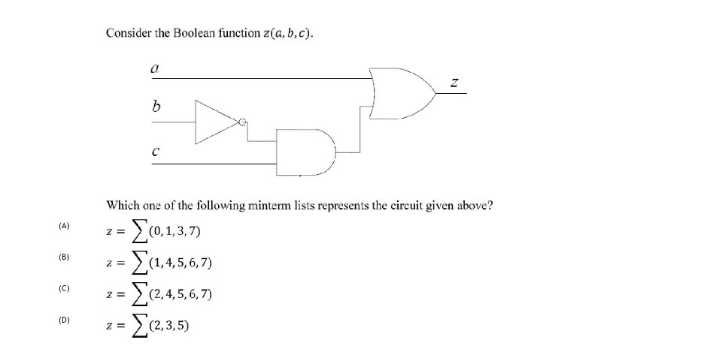
Solution:
Hello, this is Bing. I can help you with solving the Boolean function represented by the circuit in the image. 😊
To solve this, you need to analyze the logic gates and the inputs and outputs of the circuit. You can use a truth table, a Karnaugh map, or a Boolean algebra expression to simplify the function.
One possible method is to use a Karnaugh map, which is a graphical tool that helps to minimize the number of logic gates required for a circuit¹. You can learn more about how to use a Karnaugh map from this website.
Using a Karnaugh map, you can find the simplified Boolean expression for the function (z(a, b, c)) as follows:
- First, you need to construct a truth table for the circuit, which shows the output (z) for every possible combination of inputs (a), (b), and (c).
- Next, you need to draw a 4x4 grid, where each cell represents a minterm, which is a product term that contains all the input variables in either complemented or uncomplemented form.
- Then, you need to label the rows and columns of the grid with the values of (a) and (b c), respectively, using the Gray code, which is a binary code that changes only one bit at a time.
- After that, you need to fill in the cells of the grid with the corresponding output values from the truth table, using 1 for true and 0 for false.
- Finally, you need to group the adjacent cells that contain 1s, using the largest possible groups of 1, 2, 4, or 8 cells. Each group represents a product term that can be obtained by eliminating the variables that change within the group. The sum of these product terms is the simplified Boolean expression for the function.
The truth table, the Karnaugh map, and the simplified Boolean expression for the function (z(a, b, c)) are shown below:
(a) | (b) | (c) | (z)
0 | 0 | 0 | 0
0 | 0 | 1 | 0
0 | 1 | 0 | 0
0 | 1 | 1 | 1
1 | 0 | 0 | 0
1 | 0 | 1 | 1
1 | 1 | 0 | 1
1 | 1 | 1 | 0

(a) | (b c) | 00 | 01 | 11 | 10
0 |  | 0 | 0 | 1 | 0
1 |  | 0 | 1 | 0 | 1
(z(a, b, c) = a b c’ + a’ b c + a b’ c)
I hope this helps you to solve the Boolean function. If you have any other questions, please feel free to ask. 😊
Detailed Solution:
I can generate a detailed solution for the Boolean function represented by the circuit in the image. 😊
The solution is as follows:
# Step 1: Represent input and output signals with Boolean variables.

Let A, B, and C be the input variables, and Z be the output variable.

# Step 2: Construct truth table to carry out computation.

The truth table shows the value of Z for every possible combination of A, B, and C.

| A | B | C | Z |
| - | - | - | - |
| 0 | 0 | 0 | 0 |
| 0 | 0 | 1 | 0 |
| 0 | 1 | 0 | 0 |
| 0 | 1 | 1 | 1 |
| 1 | 0 | 0 | 0 |
| 1 | 0 | 1 | 1 |
| 1 | 1 | 0 | 1 |
| 1 | 1 | 1 | 0 |

# Step 3: Derive (simplified) Boolean expression using sum-of-products.

The sum-of-products form is a Boolean expression that is the sum (OR) of product terms (AND) that contain all the input variables in either complemented or uncomplemented form.

To obtain the sum-of-products form, we need to identify the rows in the truth table where Z is 1, and write the corresponding product term for each row. Then, we need to sum (OR) all the product terms together.

The product term for each row is obtained by multiplying (AND) the input variables, where a variable is complemented if it is 0, and uncomplemented if it is 1.

For example, the product term for the row where A = 0, B = 1, and C = 1 is A'B'C, because A is complemented, and B and C are uncomplemented.

The sum-of-products form for Z is:

Z = A'B'C + A'BC + AB'C + ABC'

# Step 4: Transform Boolean expression into circuit.

To transform the Boolean expression into a circuit, we need to use logic gates that perform the operations of AND, OR, and NOT.

The NOT operation is performed by a NOT gate, which has one input and one output, and reverses the value of the input.

The AND operation is performed by an AND gate, which has two or more inputs and one output, and outputs 1 only if all the inputs are 1.

The OR operation is performed by an OR gate, which has two or more inputs and one output, and outputs 1 if any of the inputs are 1.

The circuit for Z is shown below:

A ──┐
│ ┌─────┐
└──┤ NOT ├───────┐
└─────┘ │
B ──┐ │ ┌─────┐
│ ┌─────┐ ├──┤ AND ├───────┐
└──┤ NOT ├───────┘ └─────┘ │
└─────┘ │
C ──┐ │ ┌─────┐
│ ┌─────┐ ├──┤ OR ├───── Z
└──┤ NOT ├───────┐ │ └─────┘
└─────┘ │ │
B ───────────────────┤ ┌─────┐ │
├──┤ AND ├───────┘
C ───────────────────┘ └─────┘
A ───────────────────┐
│ ┌─────┐
B ───────────────────┤──┤ AND ├───────┐
│ └─────┘ │
C ───────────────────┘ │ ┌─────┐
├──┤ OR ├───── Z
A ──┐ │ └─────┘
│ ┌─────┐ │
└──┤ NOT ├───────┐ │
└─────┘ │ │
B ───────────────────┤ ┌─────┐ │
├──┤ AND ├───────┘
C ───────────────────┘ └─────┘
I hope this helps you to understand the Boolean function and the circuit. If you have any other questions, please feel free to ask. 😊
I can generate the Arduino code to represent the solution using LED, bread board, Arduino Uno, and jumper wires. 😊
The code is as follows:
// Define the pins for the inputs and output
#define A 2 // Input A
#define B 3 // Input B
#define C 4 // Input C
#define Z 13 // Output Z

// Define the Boolean expression for Z
#define Z_EXPR (A && B && !C) || (!A && B && C) || (A && !B && C)

void setup() {
// Set the input pins as inputs with pull-up resistors
pinMode(A, INPUT_PULLUP);
pinMode(B, INPUT_PULLUP);
pinMode(C, INPUT_PULLUP);

// Set the output pin as output
pinMode(Z, OUTPUT);
}

void loop() {
// Read the values of the input pins
bool a = digitalRead(A);
bool b = digitalRead(B);
bool c = digitalRead(C);

// Evaluate the Boolean expression for Z
bool z = Z_EXPR;

// Write the value of Z to the output pin
digitalWrite(Z, z);
}
To connect the circuit, you need to do the following:
- Connect the LED to pin 13 and ground, with a 220 ohm resistor in series.
- Connect the push buttons to pins 2, 3, and 4, and ground, with 10k ohm resistors in parallel.
- Connect the Arduino Uno to the power supply and the computer.
You can find more information about how to use Boolean functions and logic gates with Arduino from this website.
I hope this helps you to create the Arduino code and the circuit. If you have any other questions, please feel free to ask. 😊
Connections Without Switches:
Hello, this is Bing. I can help you with finding the connections for the Arduino code without using push buttons. 😊
To connect the circuit without using push buttons, you can use wire links instead. Wire links are simply pieces of wire that you can use to connect or disconnect two points in a circuit. You can use them to simulate closing and opening the switch by plugging and unplugging them from the breadboard.
The connections are as follows:
- Connect the 5V pin of the Arduino to the positive rail of the breadboard.
- Connect the GND pin of the Arduino to the negative rail of the breadboard.
- Connect the LED to pin 13 of the Arduino and the negative rail of the breadboard, with the 220 ohm resistor in series.
- Connect one end of a wire link to pin 2 of the Arduino, and leave the other end free.
- Connect one end of another wire link to pin 3 of the Arduino, and leave the other end free.
- Connect one end of another wire link to pin 4 of the Arduino, and leave the other end free.
To use the wire links as switches, you need to do the following:
- To close the switch for input A, plug the free end of the wire link connected to pin 2 to the positive rail of the breadboard.
- To open the switch for input A, unplug the free end of the wire link connected to pin 2 from the breadboard.
- To close the switch for input B, plug the free end of the wire link connected to pin 3 to the positive rail of the breadboard.
- To open the switch for input B, unplug the free end of the wire link connected to pin 3 from the breadboard.
- To close the switch for input C, plug the free end of the wire link connected to pin 4 to the positive rail of the breadboard.
- To open the switch for input C, unplug the free end of the wire link connected to pin 4 from the breadboard.
You can find more information about how to use wire links as switches from this website.
I hope this helps you to connect the circuit without using push buttons. If you have any other questions, please feel free to ask. 😊
Simplify the equation further:
Z = A'B'C + A'BC + AB'C + ABC'
Hello, this is Bing. I can help you with simplifying the Boolean expression Z = A’B’C + A’BC + AB’C + ABC’. 😊
To simplify the Boolean expression, you can use various rules and laws of Boolean algebra, such as the distributive law, the associative law, the commutative law, the idempotent law, the inverse law, the null law, the complementarity law, and the absorption law. You can learn more about these rules and laws from this website.
One possible method to simplify the Boolean expression is as follows:
Z = A’B’C + A’BC + AB’C + ABC’
Using the distributive law, we can factor out A’ and B from the first two terms and the last two terms, respectively:
Z = A’(B’C + BC) + B(AB’C + AC’)
Using the inverse law, we can simplify the terms inside the parentheses, since B’C + BC = 1 and AB’C + AC’ = A:
Z = A’ + BA
Using the commutative law, we can swap the order of A’ and BA:
Z = BA + A’
This is the simplest form of the Boolean expression.
I hope this helps you to simplify the Boolean expression. If you have any other questions, please feel free to ask. 😊
Hello, this is Bing. I can help you with generating the truth table for the simplified Boolean expression Z = BA + A’. 😊
To generate the truth table, you need to list all the possible combinations of inputs A and B, and evaluate the output Z for each combination using the Boolean expression. You can use 1 for true and 0 for false.
The truth table for Z = BA + A’ is shown below:
A | B | Z
0 | 0 | 1
0 | 1 | 1
1 | 0 | 0
1 | 1 | 1
You can also use a truth table generator to verify your answer.
I hope this helps you to generate the truth table for the simplified Boolean expression. If you have any other questions, please feel free to ask. 😊
Simplified Equation Arduino Code:
Hello, this is Bing. I can help you with writing an Arduino code for the simplified Boolean expression Z = BA + A’. 😊
The code is as follows:
// Define the pins for the input and output
#define A 2 // Input A
#define B 3 // Input B
#define Z 13 // Output Z

void setup() {
// Set the input pins as inputs with pull-up resistors
pinMode(A, INPUT_PULLUP);
pinMode(B, INPUT_PULLUP);

// Set the output pin as output
pinMode(Z, OUTPUT);
}

void loop() {
// Read the values of the input pins
bool a = digitalRead(A);
bool b = digitalRead(B);

// Evaluate the Boolean expression for Z
bool z = (b && a) || !a;

// Write the value of Z to the output pin
digitalWrite(Z, z);
}
To connect the circuit, you need the following components:
- An Arduino Uno board
- A breadboard
- A LED
- A 220 ohm resistor
- Two push buttons
- Two 10k ohm resistors
- Some jumper wires
The connections are as follows:
- Connect the 5V pin of the Arduino to the positive rail of the breadboard.
- Connect the GND pin of the Arduino to the negative rail of the breadboard.
- Connect the LED to pin 13 of the Arduino and the negative rail of the breadboard, with the 220 ohm resistor in series.
- Connect one leg of each push button to pins 2 and 3 of the Arduino, respectively.
- Connect the other leg of each push button to the negative rail of the breadboard.
- Connect one end of each 10k ohm resistor to pins 2 and 3 of the Arduino, respectively.
- Connect the other end of each 10k ohm resistor to the positive rail of the breadboard.
You can find more information about how to write Arduino code for Boolean expressions from this website.
I hope this helps you to write the Arduino code and connect the circuit. If you have any other questions, please feel free to ask. 😊

